ASSIGNMENT-4

Assignment Date | 21/10/2022
Student Name | Jeffrey Benison A
Student Roll Number | 95071914037
Maximum Marks | - Marks

Questions:

1. Pull an image from docker hub and run it in docker playground.
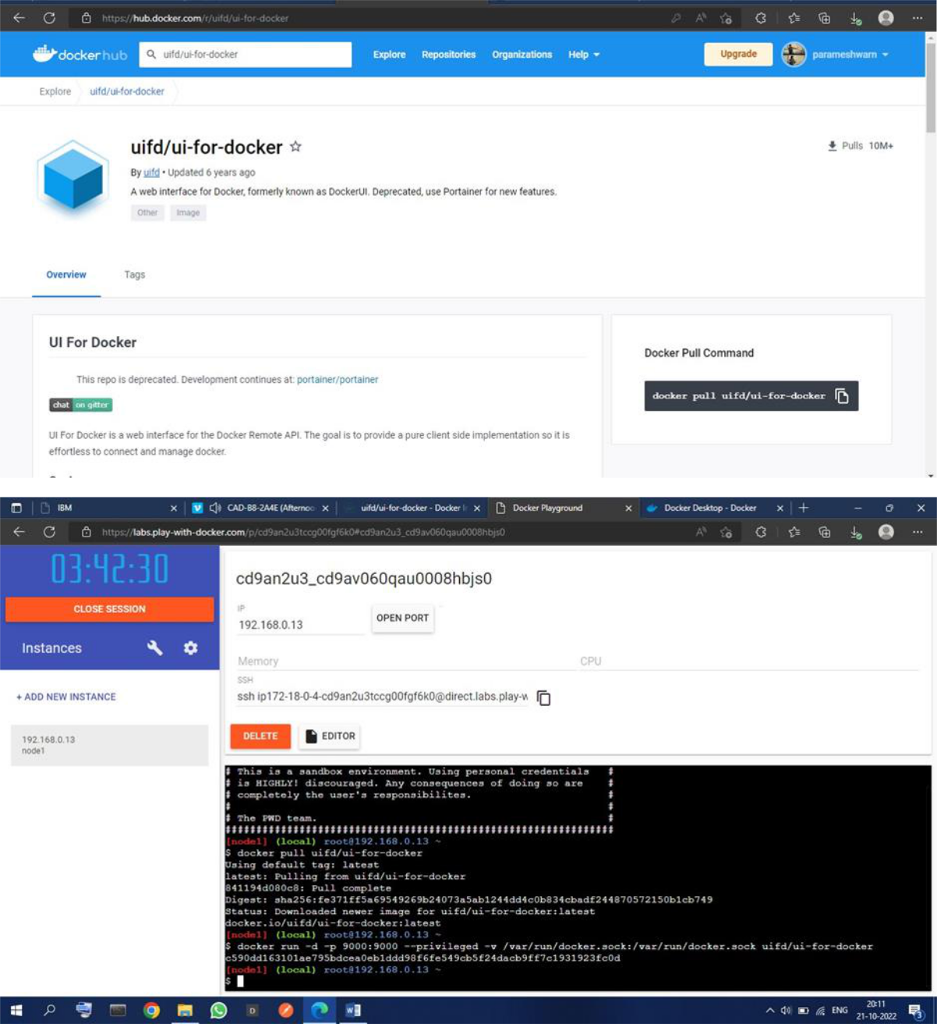
2. Create a docker file for the job portal application and deploy it in Docker desktop

application.
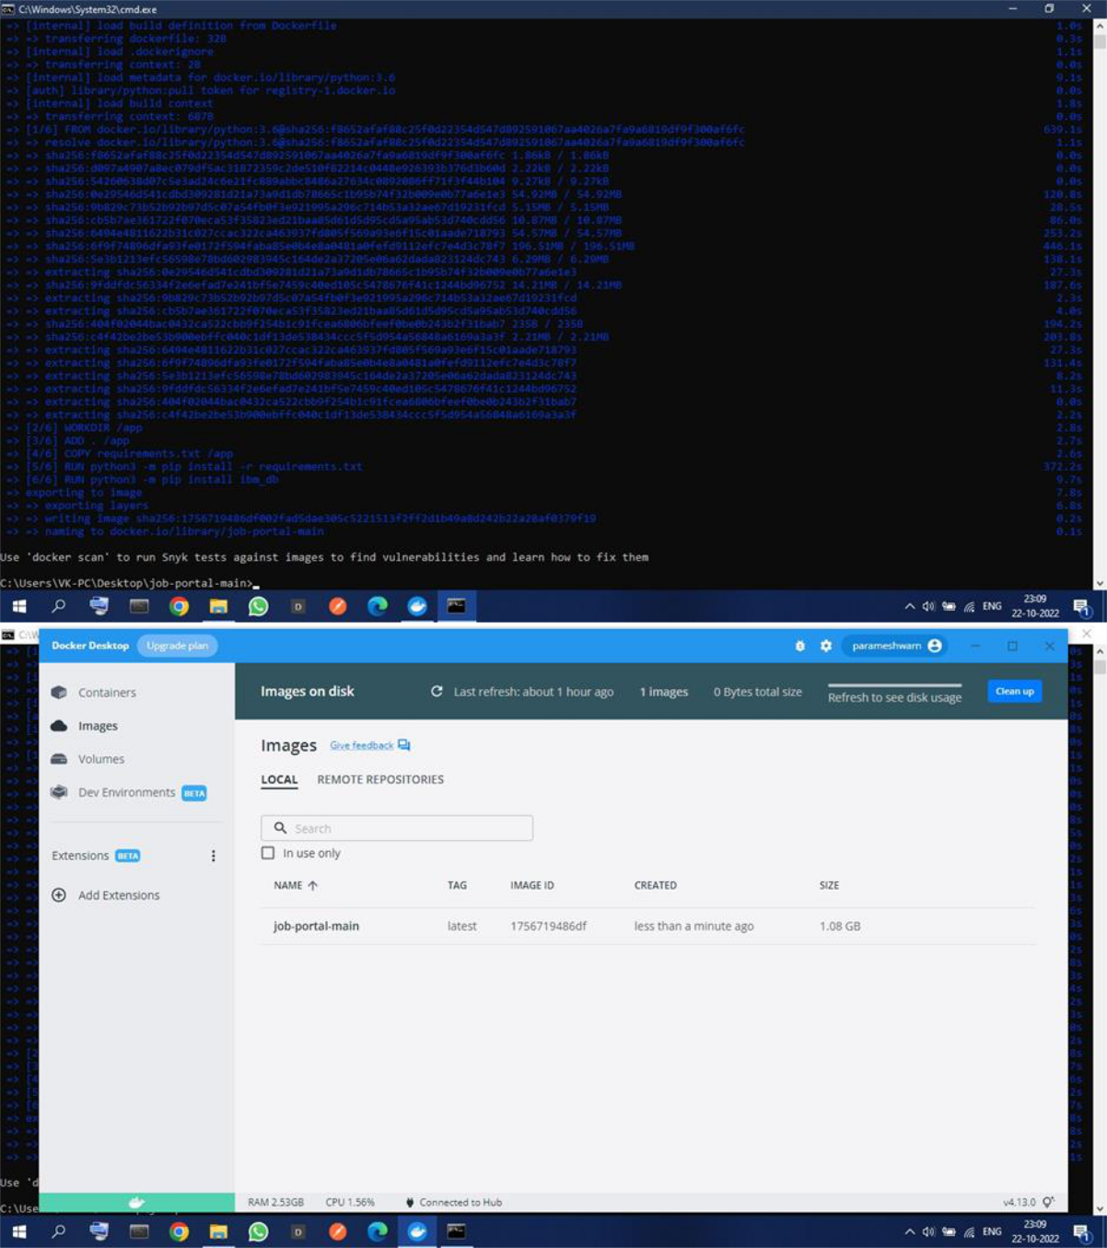

3. Create an IBM container registry and deploy helloworld app or jobportalapp.
